Deep Dive into CI and CD pipeline

About Agent Pools

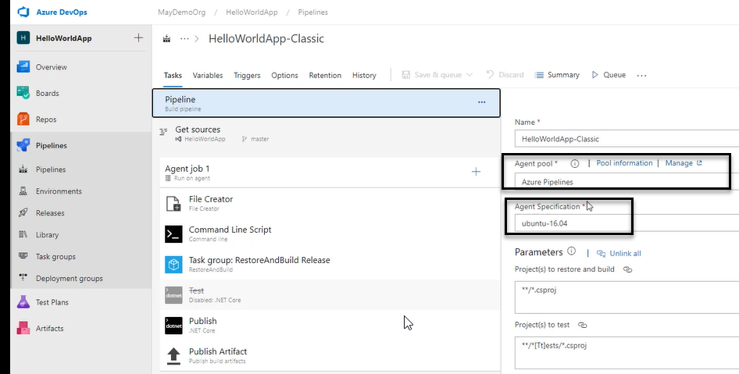

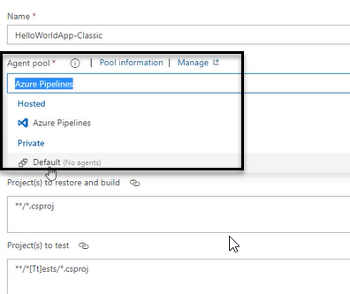

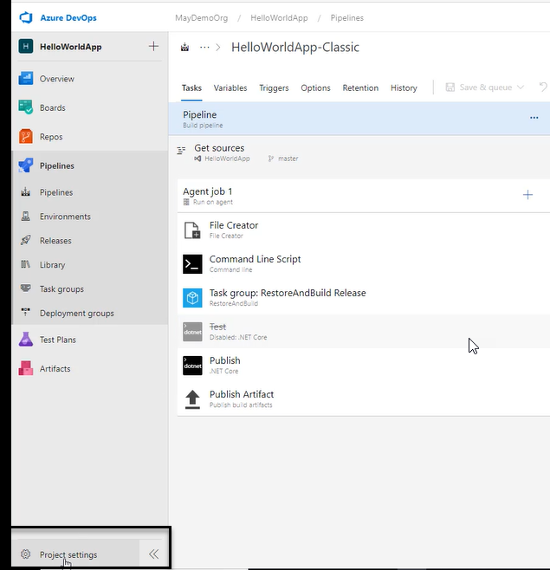

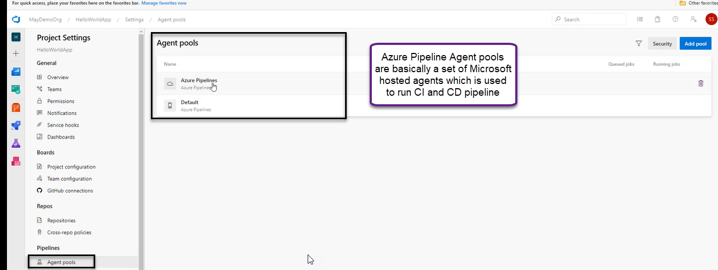

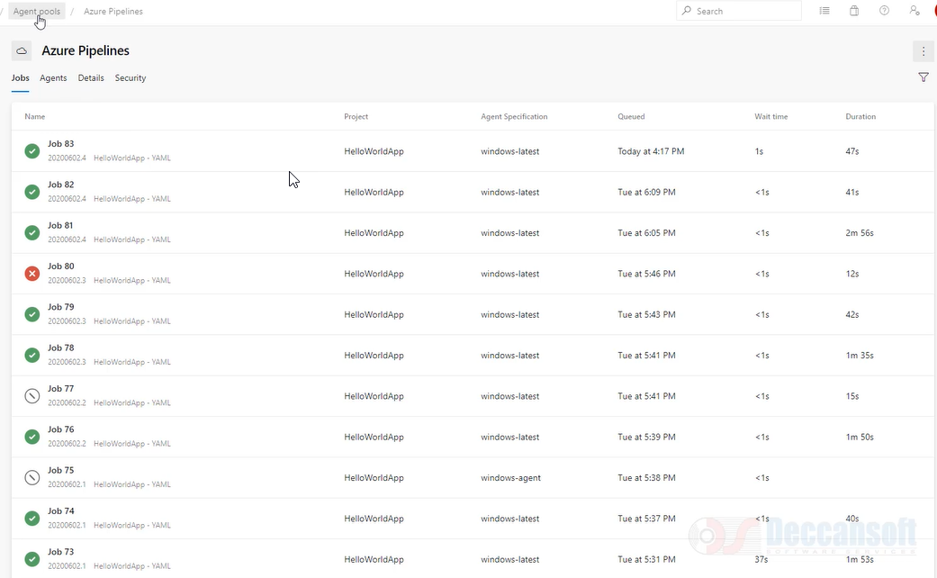

We can create self-hosted agent (Customized agent)

The self-hosted agent we need to add it to the Default one

Microsoft is responsible for Microsoft hosted agent. If have I create multiple hosted machines/own physical machine/Own VM and want to use that for execution, then instead of managing individually we are going to put all of them in group together that’s what we are calling as agent pool

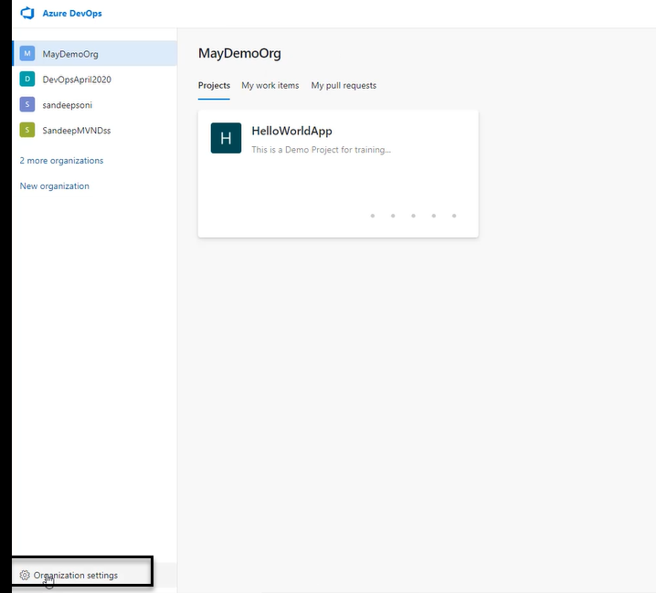

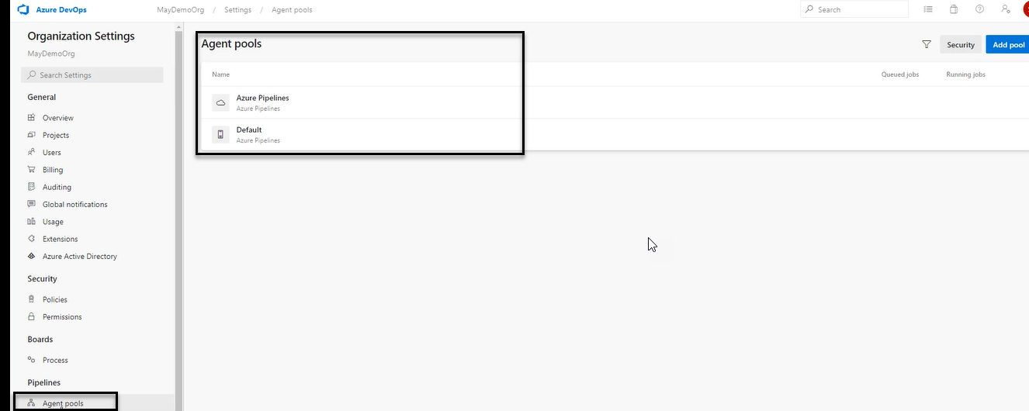

Always agent pool is created at the organization level only but certain agent pools we need to give some projects and other certain agent pools we need to give to other projects so how does it work. In the pipeline we are always going to choose an agent pool available for the project, but project agent pool is referring to organization agent pool only there is NO separate agent pool set created for the organization

All agent pools available at organization level and it may or may not available to the project

And only it is available to project they can be used in the pipeline

How to achieve the agent pool if it is created in organization settings we need to use in agent pool

For that create a new project for testing purpose

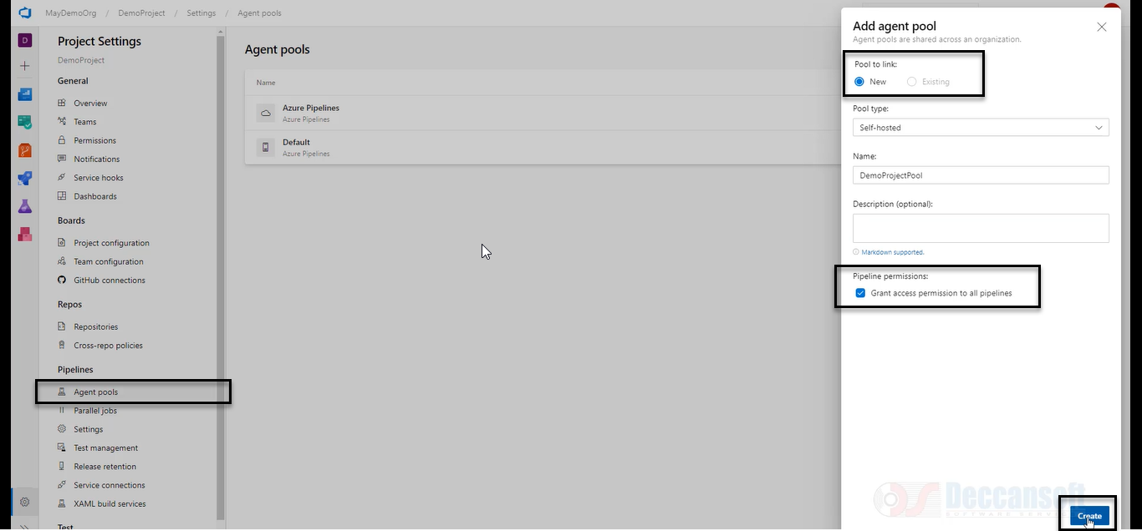

Demo project pool is created at project level

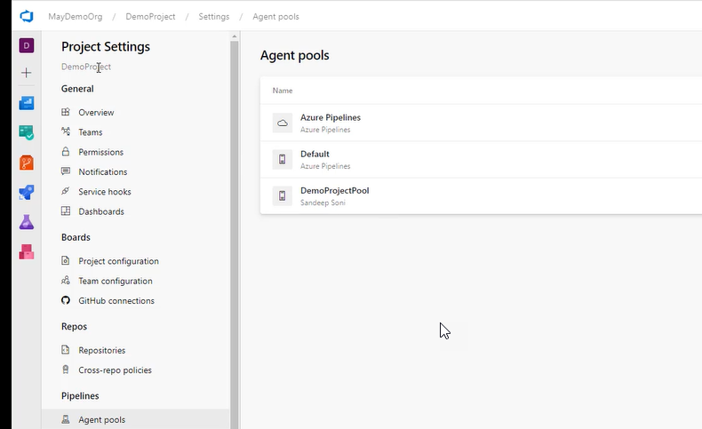

However, we see the same in organization level

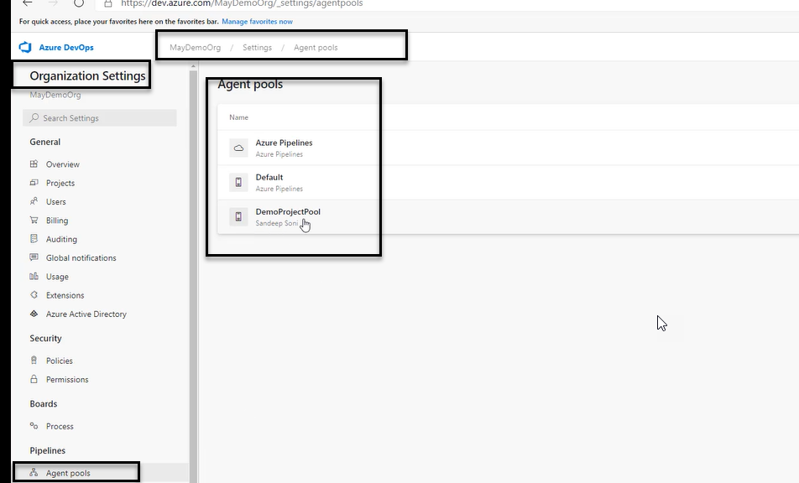

It will NOT present in another project

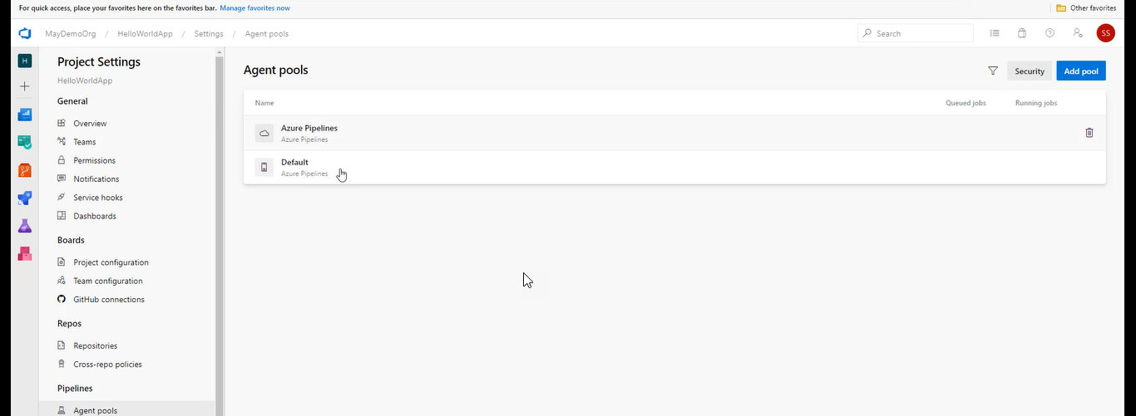

Unless the administer of the project is responsible for going here in the below location

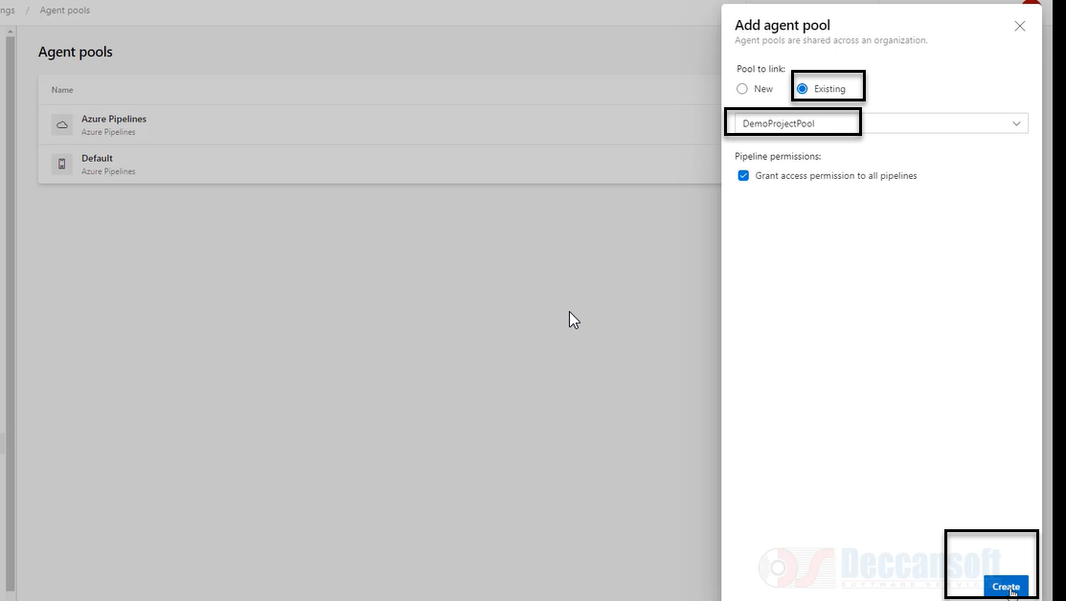

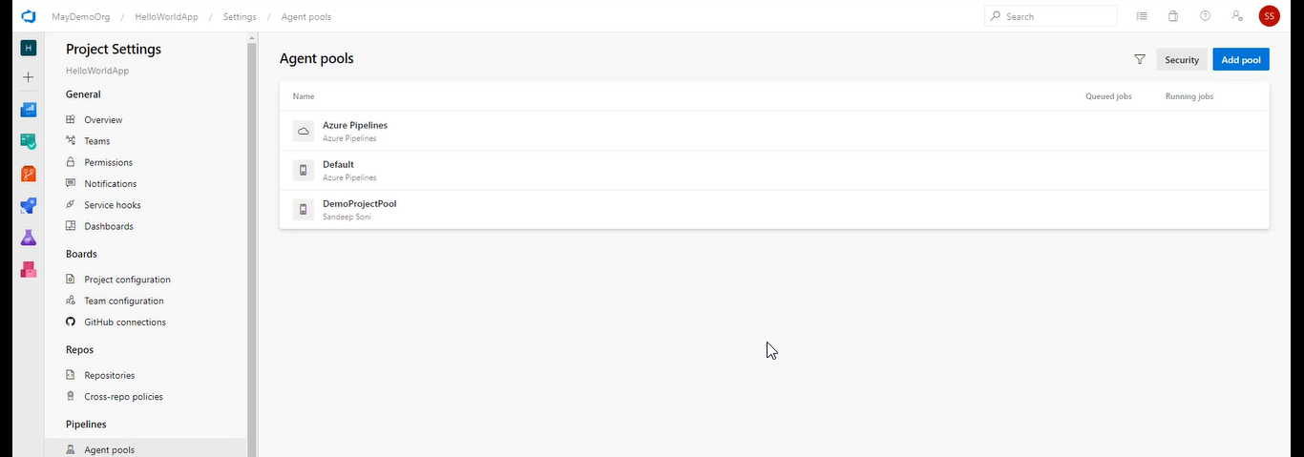

Create agent pool in organization level

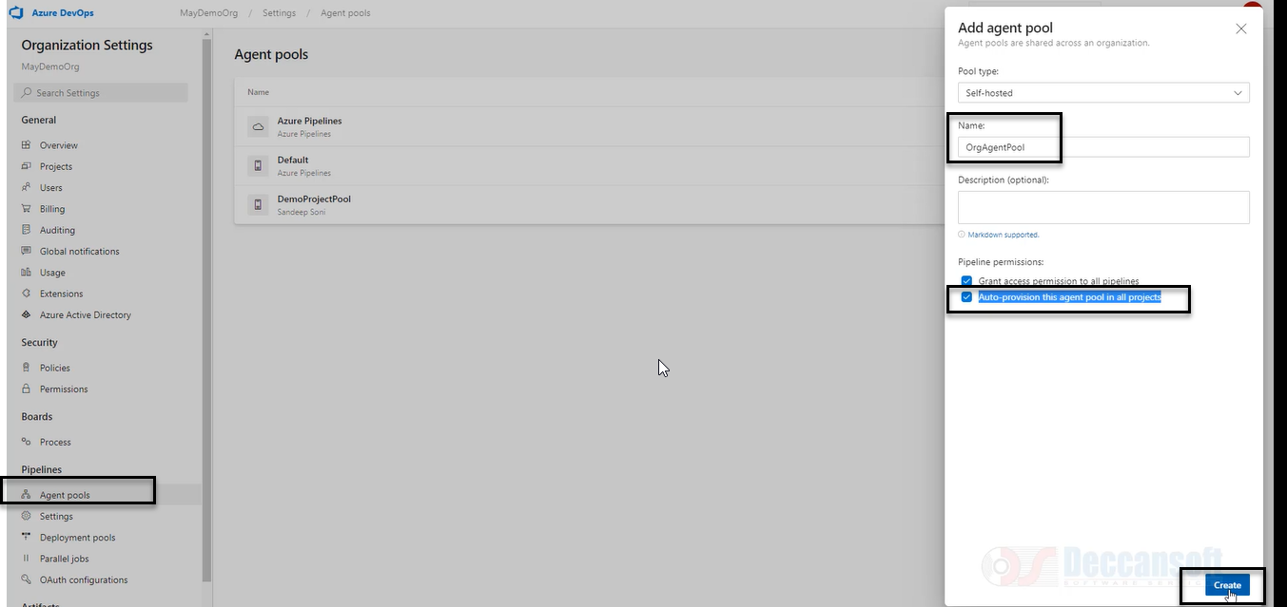

Auto Provision this agent pool in all the projects: the pool is available in all the projects

When we create the pipeline, we do not choose an agent whether it is a project A, B

Always go the project

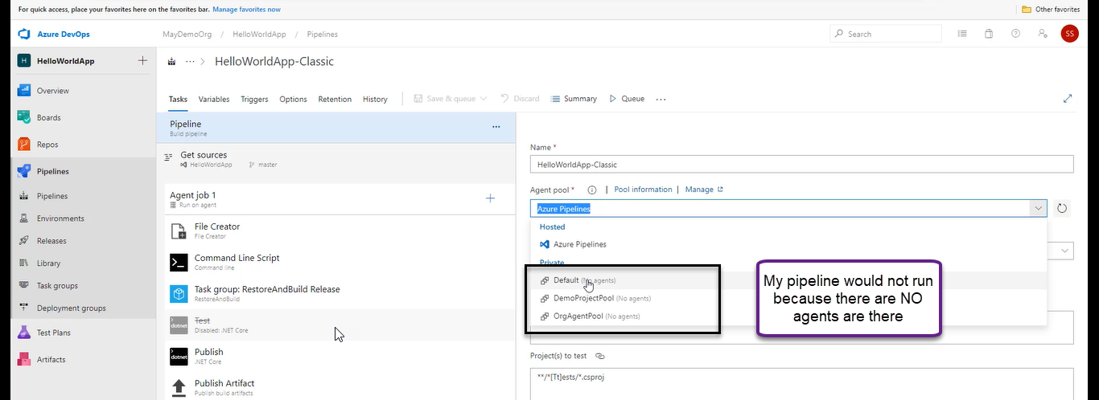

But if we select the Agent pool one of the VM which is on Agent that means one of the agents in the agent pool is going to be automatically selected agent pool is the collection of agents. Each agent can be treated as One Virtual Machine when a pipeline is executed any one agent from the pool which is selected at the time of configuring the pipeline is going to be used for execution of pipeline

For pipeline we will never select a specific agent we will always select the pool of the agent

Security of agent pools in organization settings

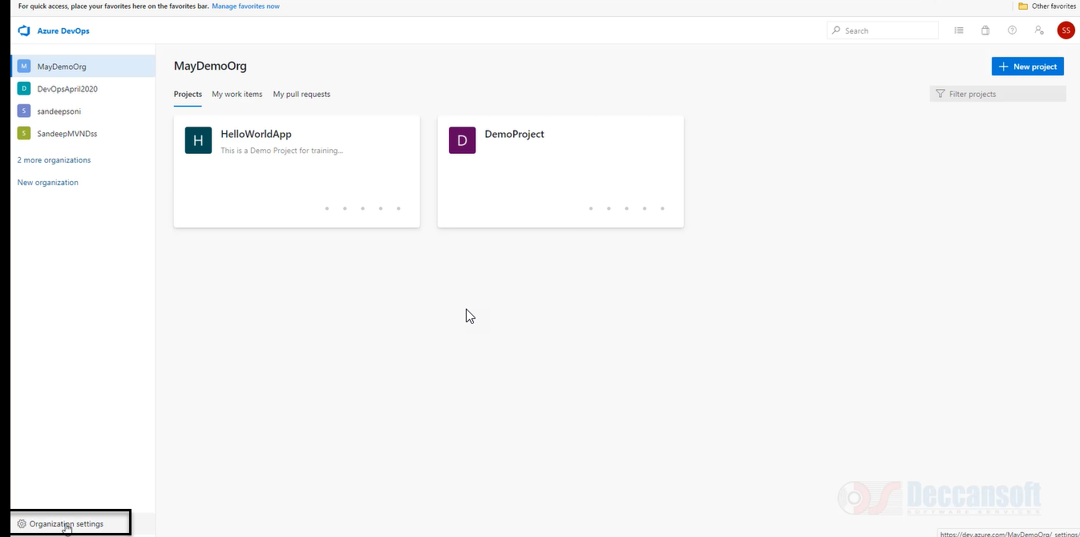

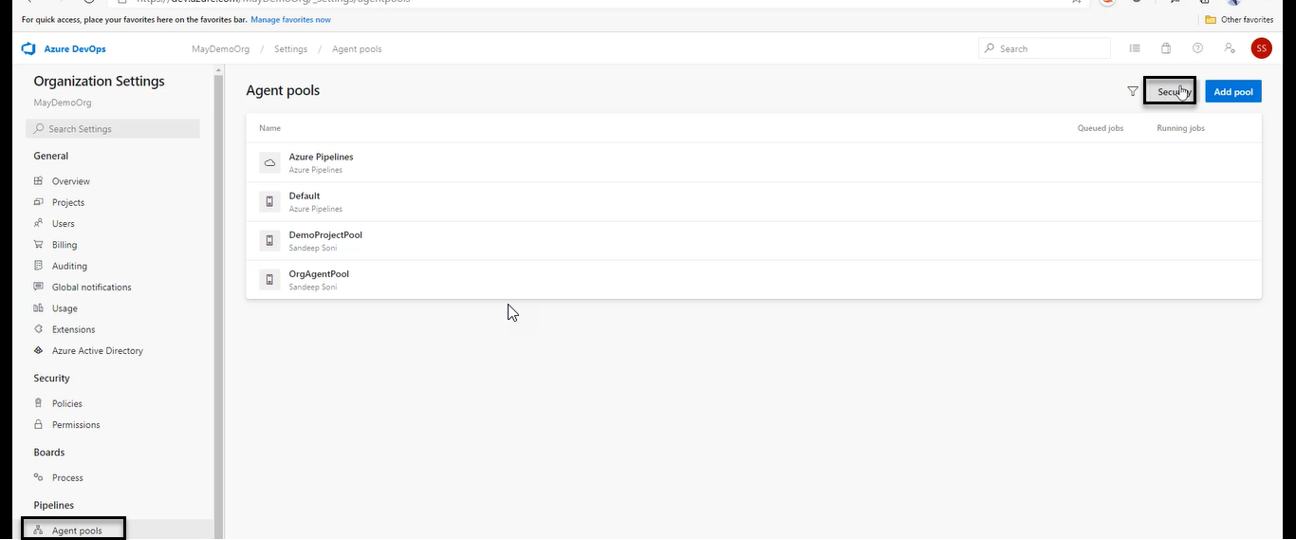

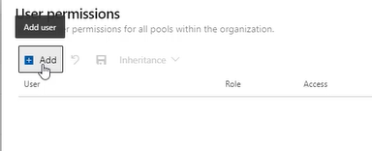

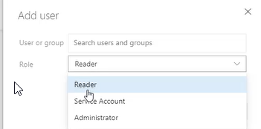

For project level

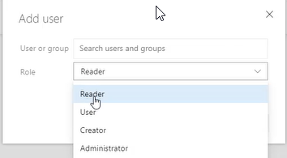

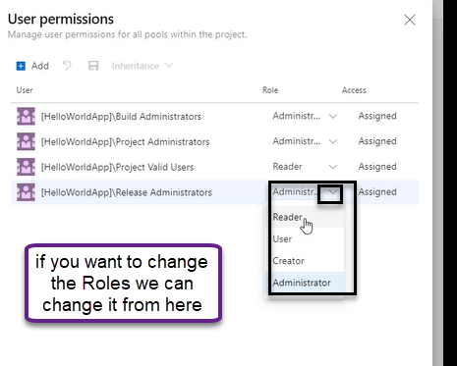

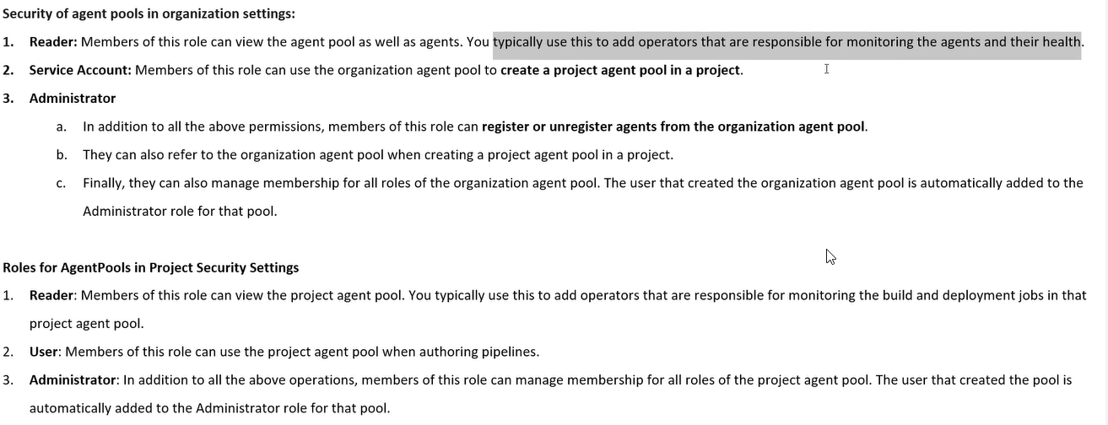

Microsoft Hosted Agents

1. About Build agents (Build and deployment)
2. Agents are of two types > Microsoft and self
3. Build pipe we can call as Run and for release pipeline we Can call it is Release

We can one of the below images as a Microsoft hosted agent

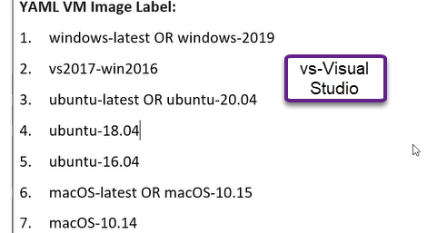

For classic pipeline

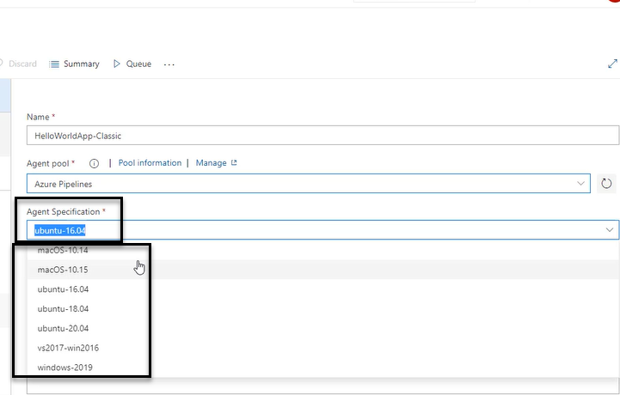

For YAML pipeline

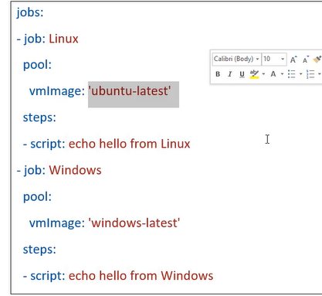

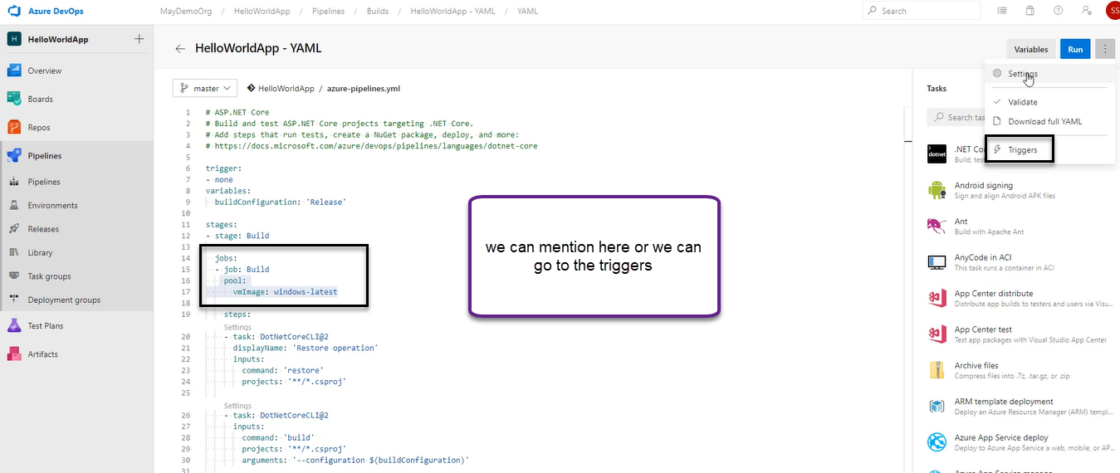

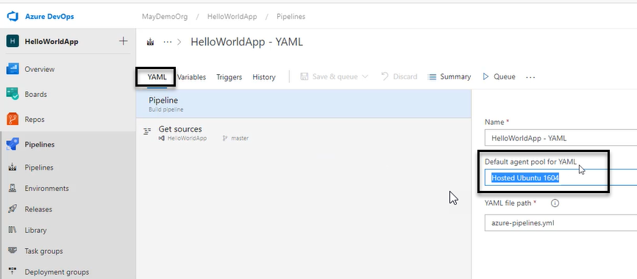

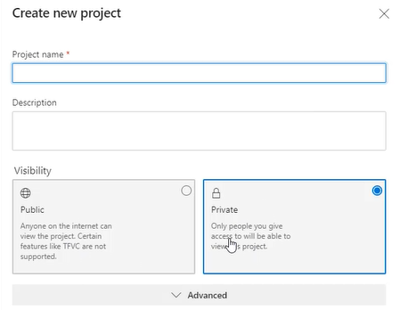

A pipeline is made up of stages and inside stages we have jobs and a stage can have one or more jobs

The particular job should not take at least 60 minutes (Job is like Dev, QA and Prod)

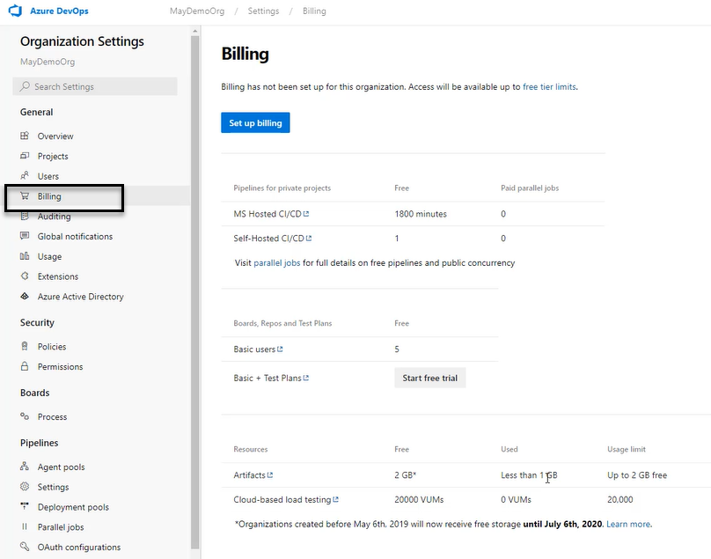

Click on parallel Jobs with respect to that link

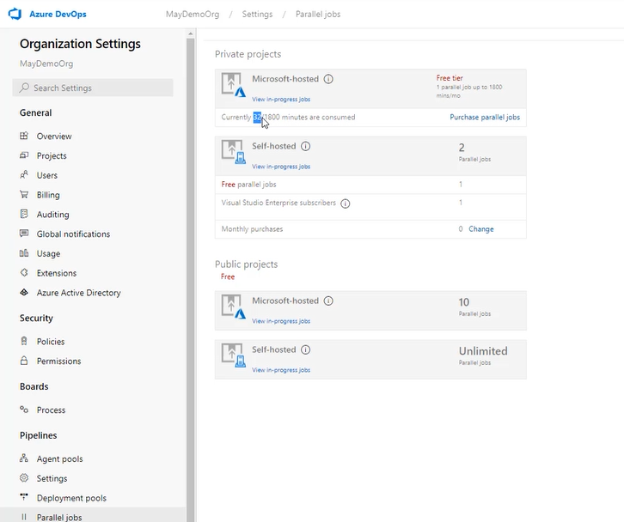

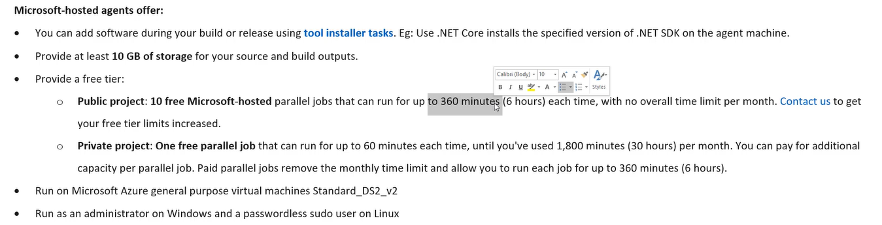

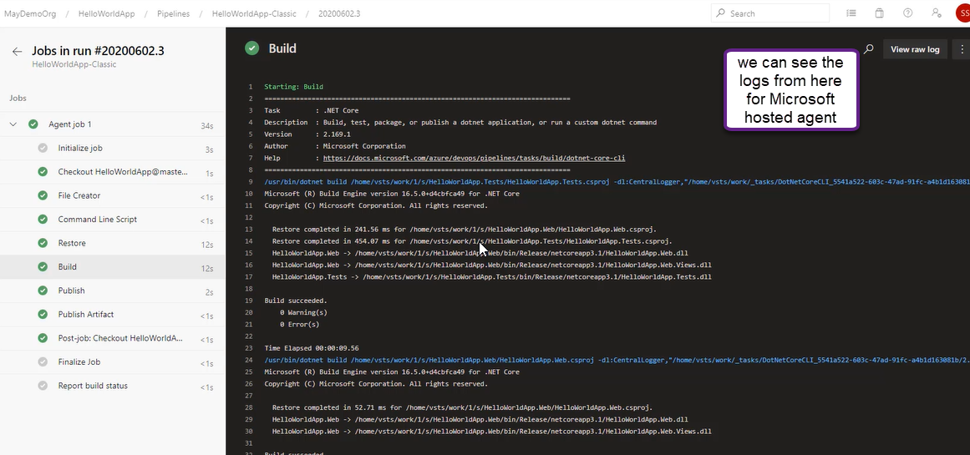

UNC is universal Network a shared drive is created in the network and you can dump everything onto the shared drive rather than keeping them in Microsoft azure agent but we cannot do in Microsoft Hosted Agent

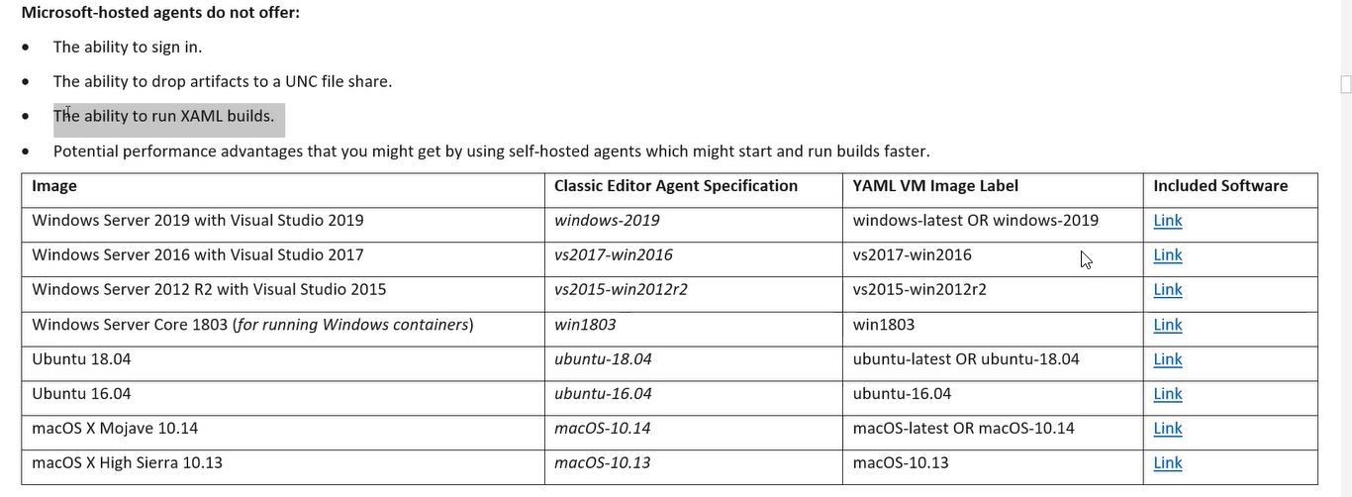

One of the important build is to restore what restore does it will try to pull all the artifacts basically it’s a Nuget packages from internet to local store

We can restore the build after the pipeline has ended for self hosted where as for Microsoft the after the pipeline is ended we can restore the build

3- Self Hosted Agent

1. In self host we can create a VM
2. In release is done the tasks you added in the pipeline is destroyed in Microsoft however in self we can install and place

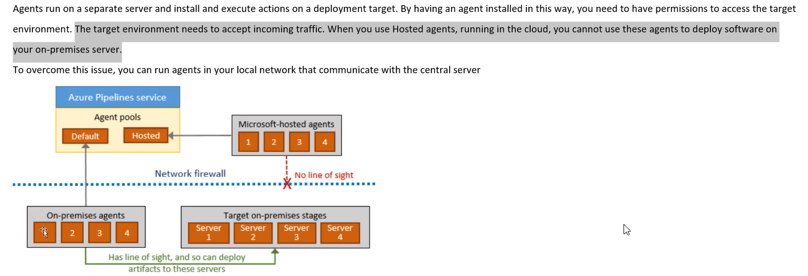

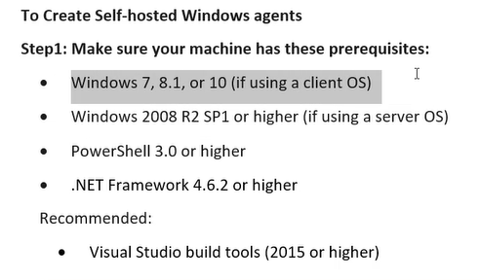

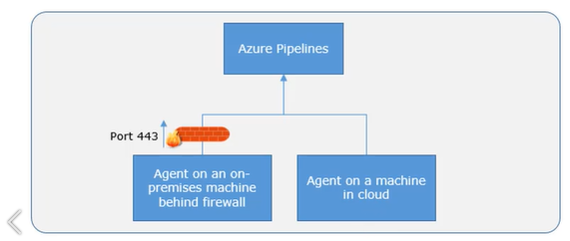

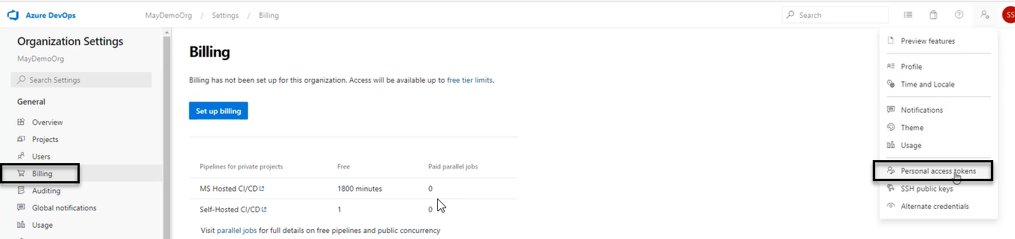

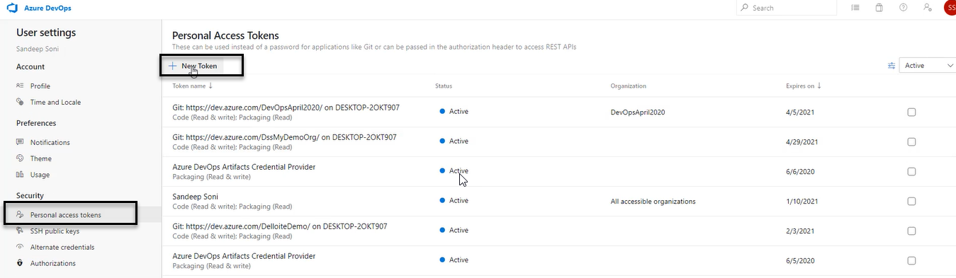

What type of things you need to do from agent we can actually define below

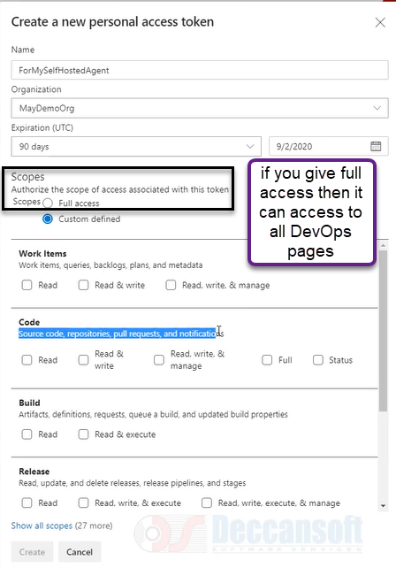

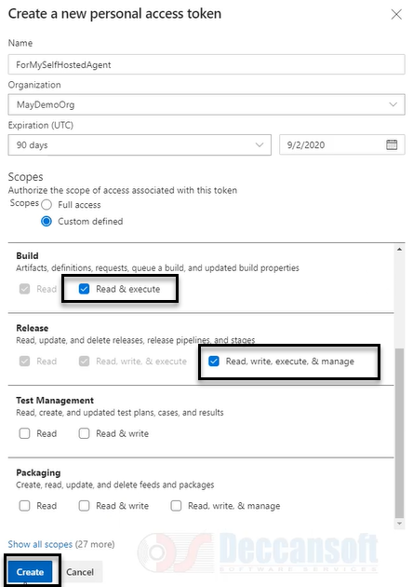

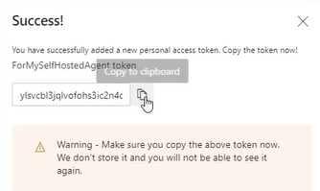

The code we need to use at the creation of agent

We need to download the agent

Go to the Agent pools in which you are going to install the agent

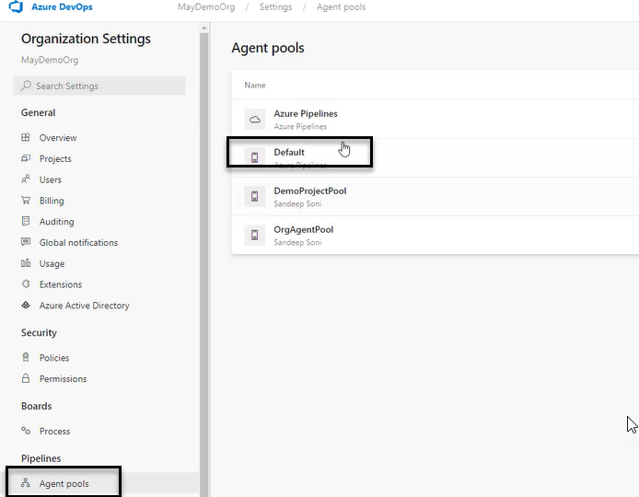

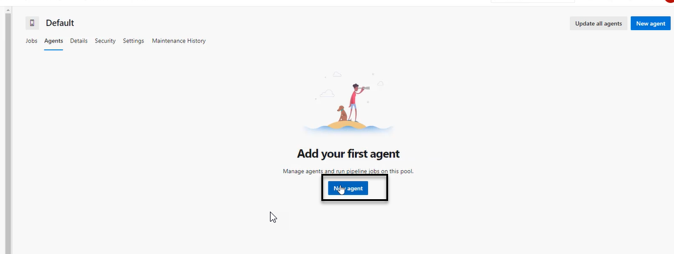

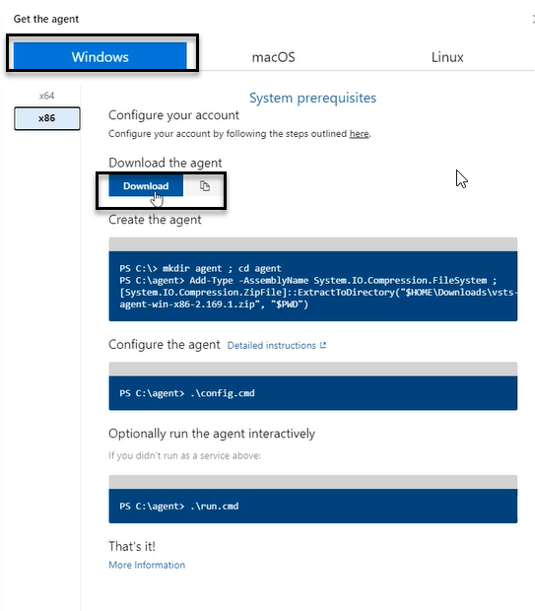



Once the software Is downloaded create a directory agent go to the directory and extract the zip file

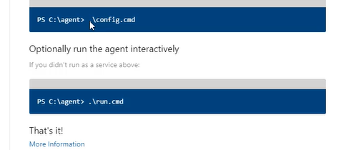

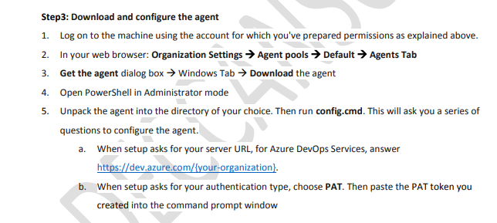

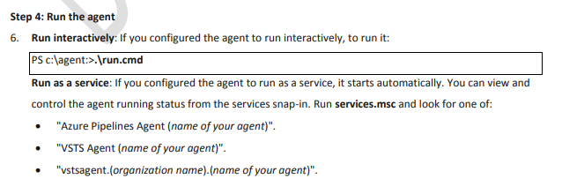

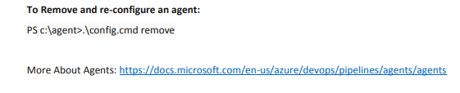

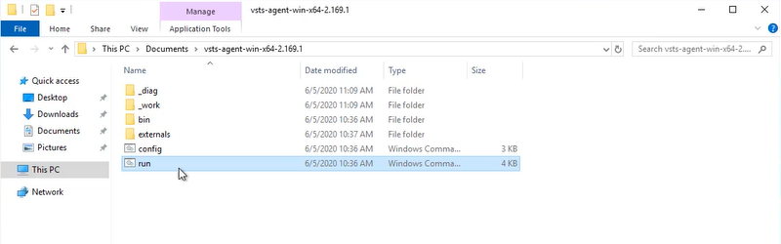

Click on run before that run the config and enter the PAT token

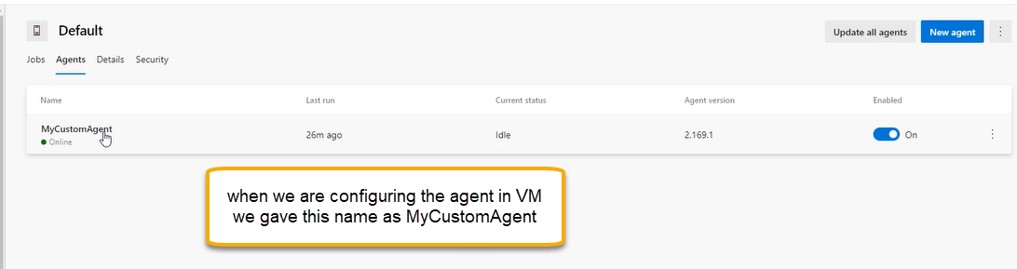

If the job is failing/success we can below location

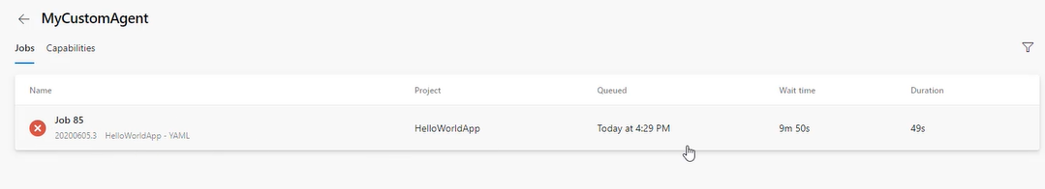

4-Pipeline Demands

1. Pipeline is attached to agent and agents needs some software

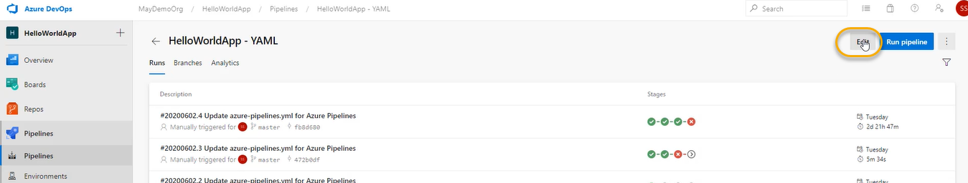

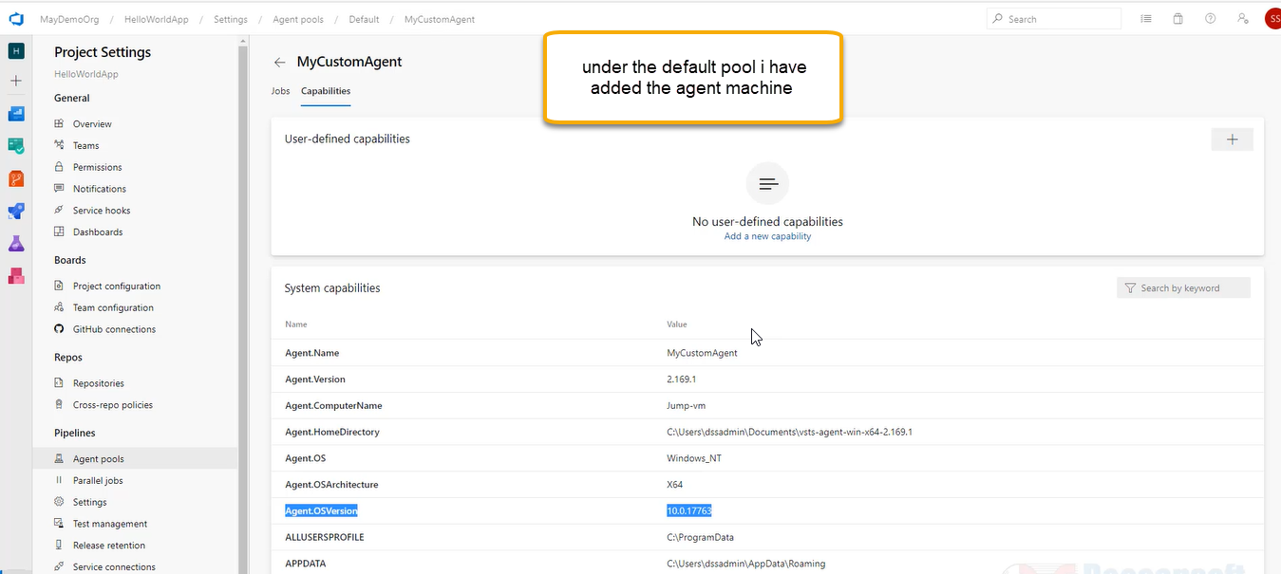

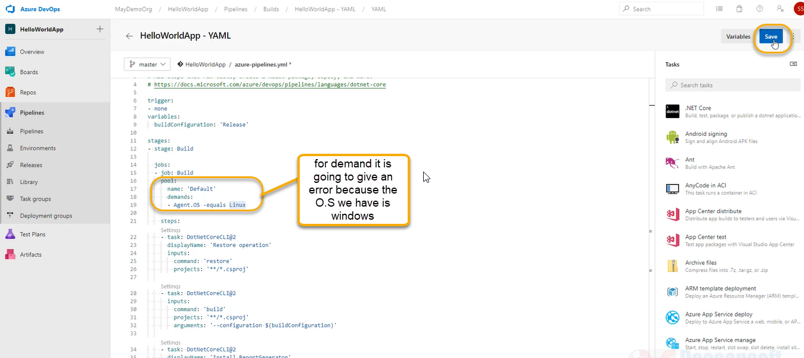

A pop up will come and gain save this

And Run and gain Run it

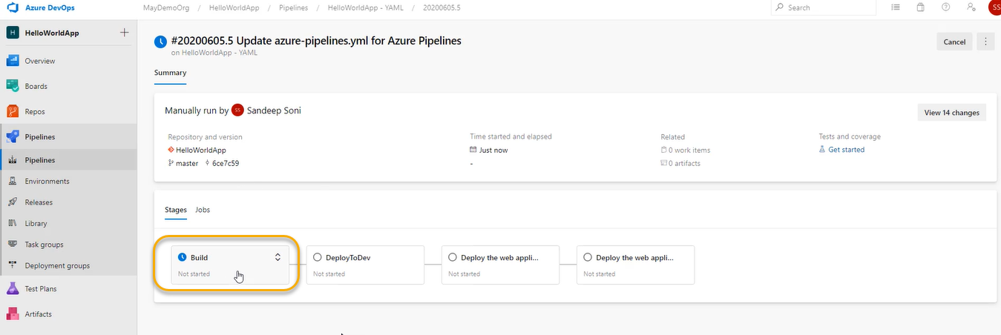

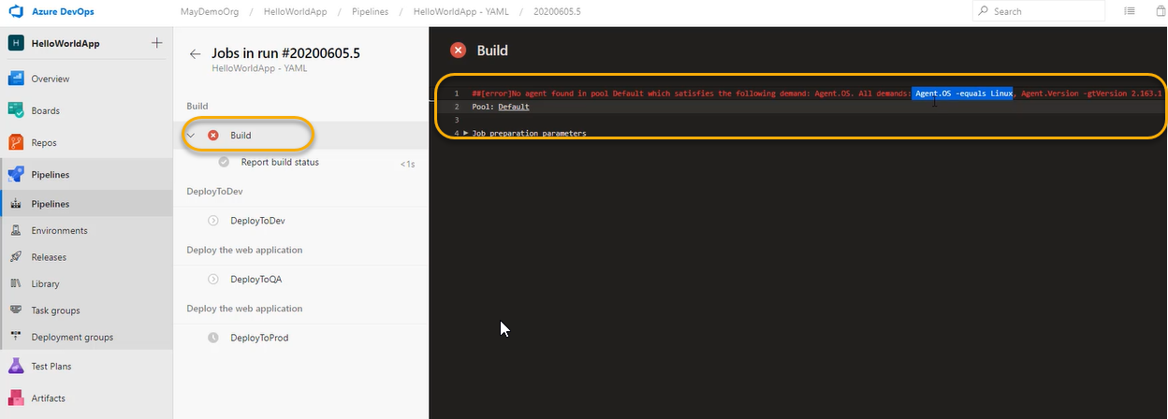

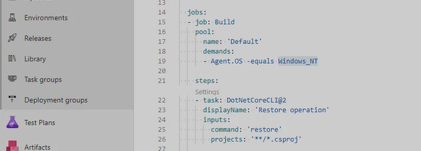

Click on Save > Save and Run > Run

We can monitor the build status from RDP where you installed the agent machine or in Azure Devops portal

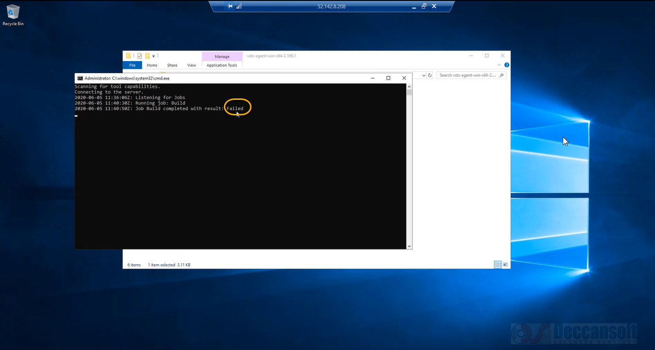

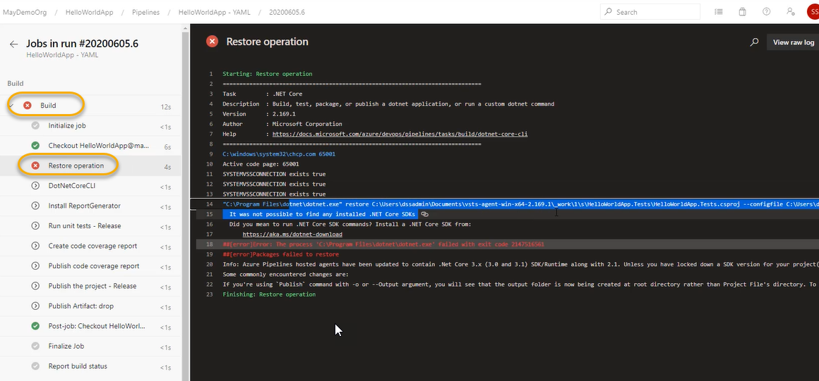

So install .dotnetsdk in RDP or all the required dependencies which we want to make use of it at the time of during the build

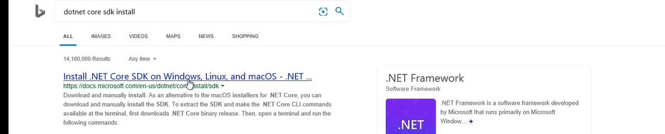

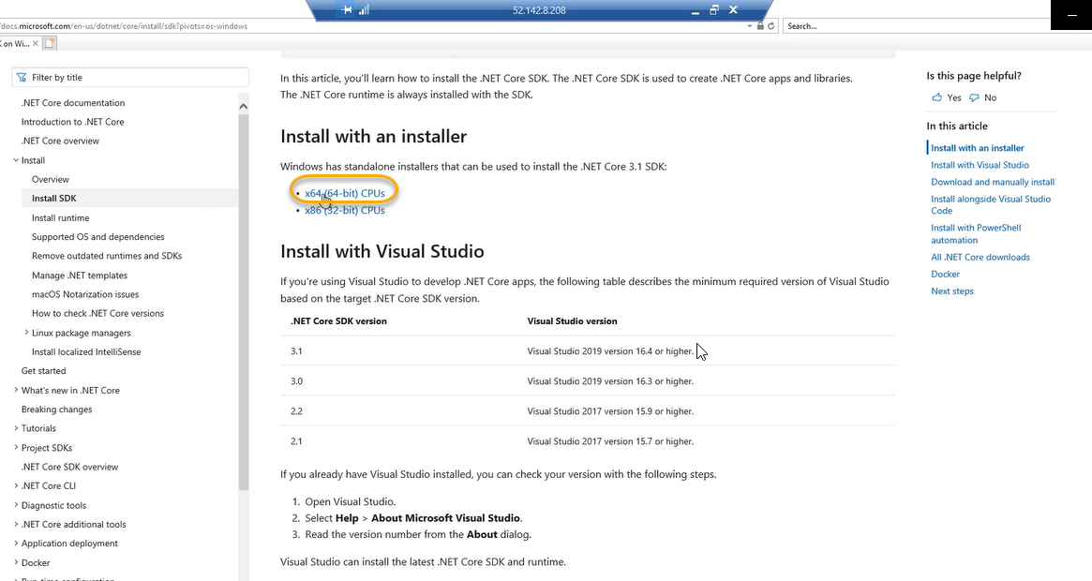

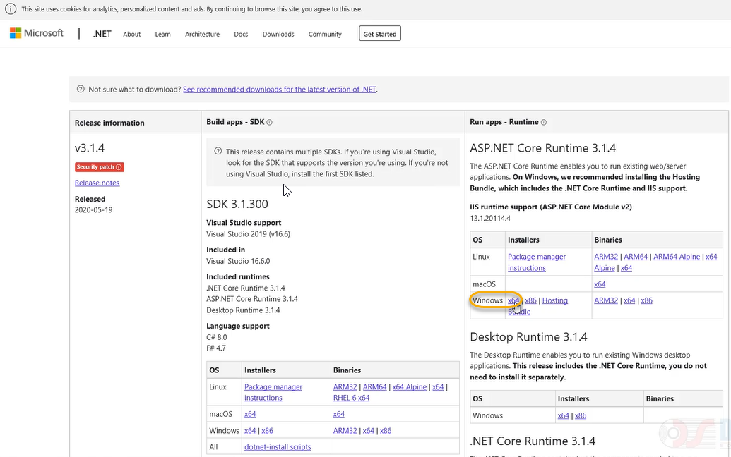



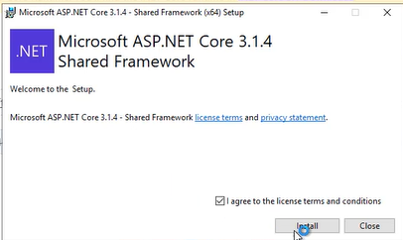

To check if it is installed or not

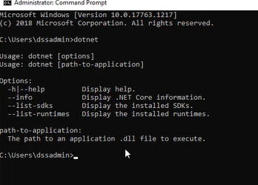

.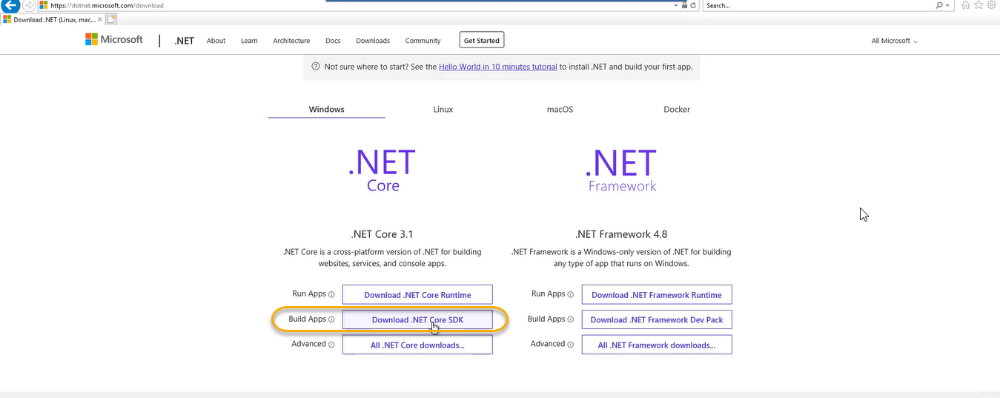

.NET Core SDK will do RESTORE OPERATION of your Build

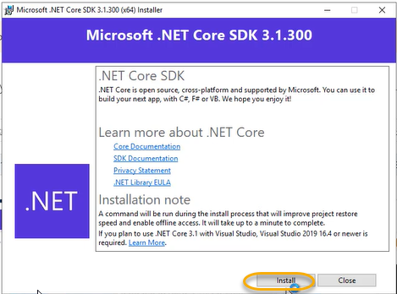

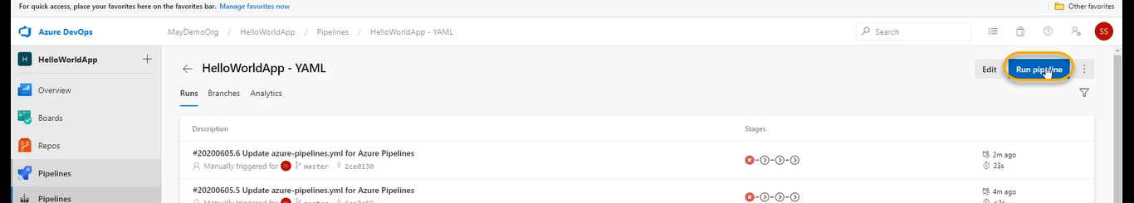

I have created VM Machine with default settings and allows for RDP connection and I have downloaded it

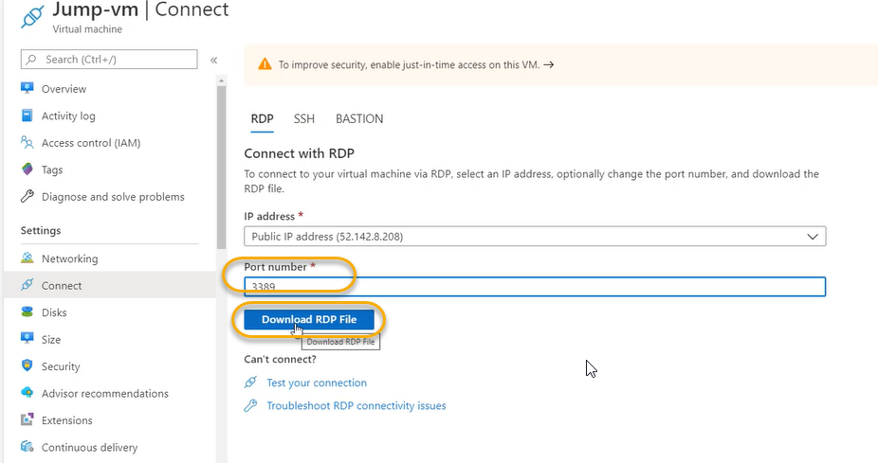

Do the RDP from VM in that particular VM machine go to the browser and go to the DevOps account download the agent from agent tool section, download the agent and install the agent and after installing the agent do the Run.exe on the agent machine

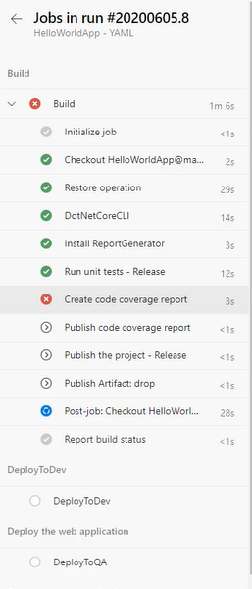

If you want to download anything in the windows server machine we need to some settings

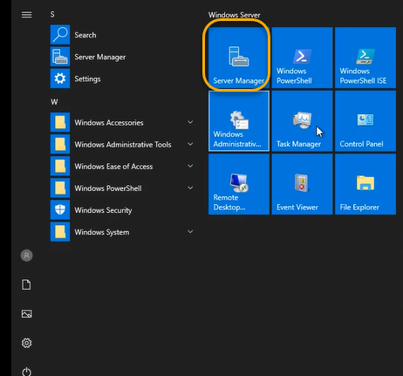

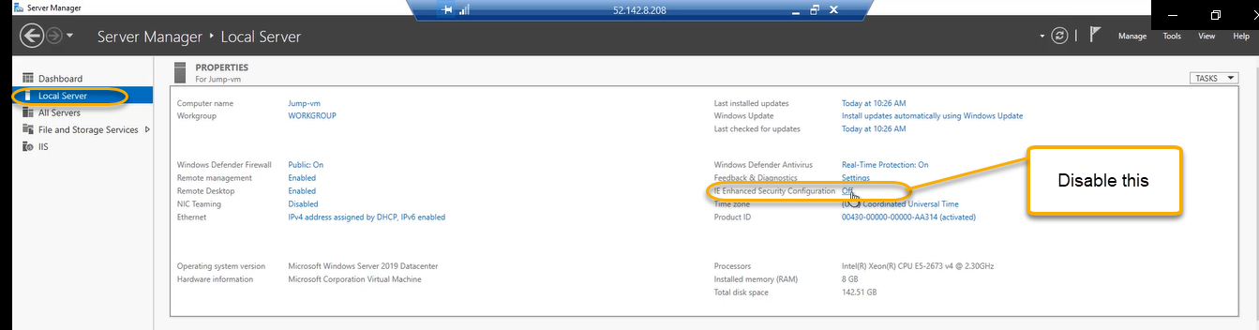

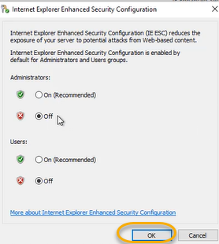

We can also add a custom demand

When my pipeline mentions agent dot as we see in the below screenshot which are system capabilities

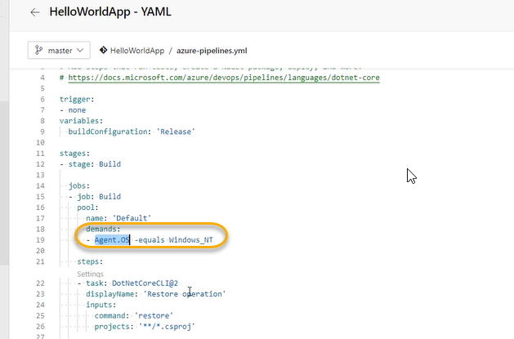

Microsoft hosted agent does not show system capabilities

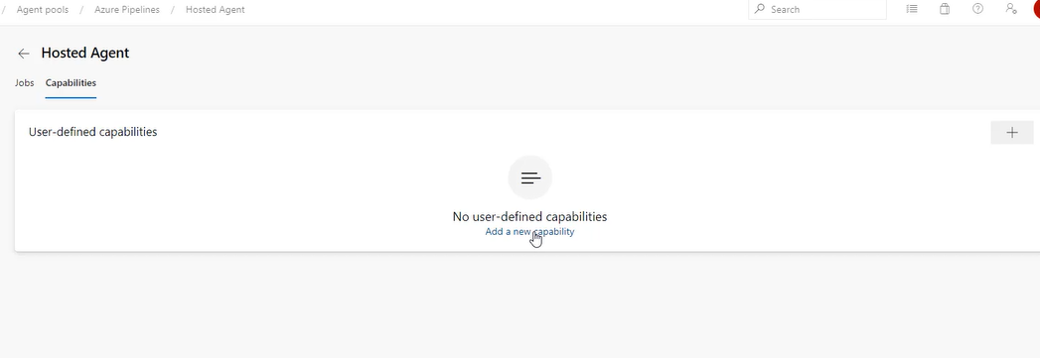

Now add a user defined capability

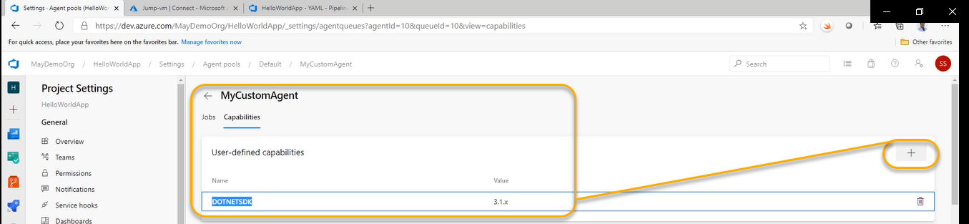

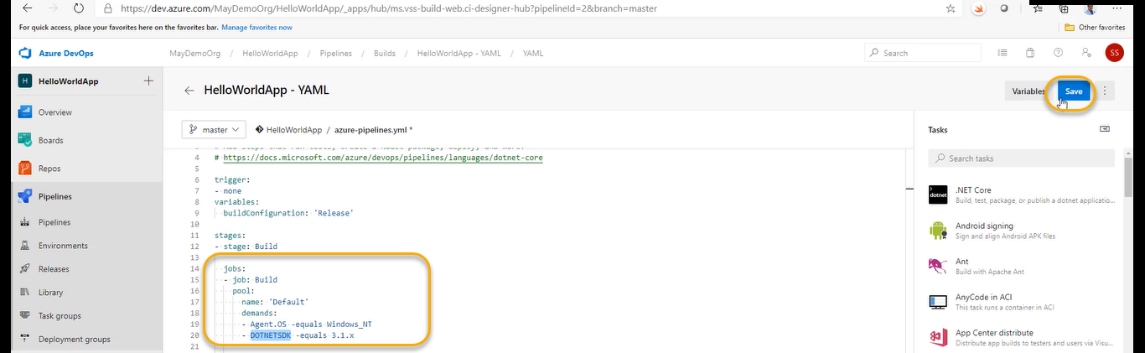

Save it and Run > Run